# Python: Reverse Words and Swap Cases

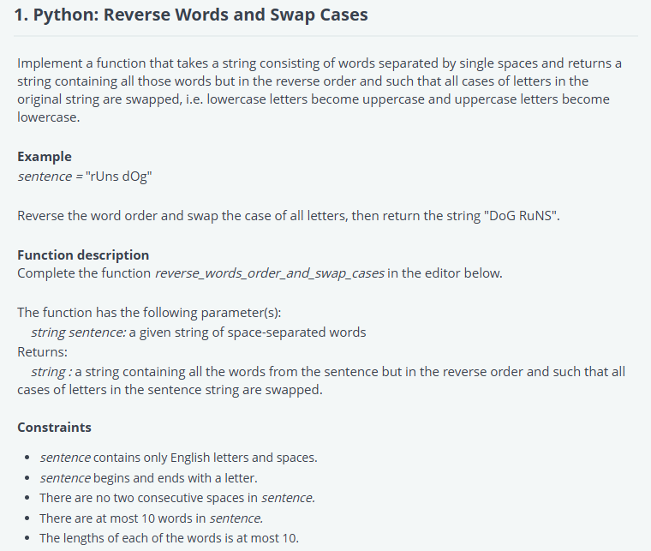

#!/bin/python

import math

import os

import random

import re

import sys

#

# Complete the 'reverse_words_order_and_swap_cases' function below.

#

# The function is expected to return a STRING.

# The function accepts STRING sentence as parameter.

#

def reverse_words_order_and_swap_cases(sentence):

    # Write your code here

    # Split the sentence into words

    words = sentence.split()

    # Reverse the order of the words

    reversed_words = words[::-1]

    # Join them back into a string with spaces and swap case

    result = ' '.join(reversed_words).swapcase()

    return result

if __name__ == '__main__':

    fptr = open(os.environ['OUTPUT_PATH'], 'w')

    sentence = raw_input()

    result = reverse_words_order_and_swap_cases(sentence)

    fptr.write(result + '\n')

    fptr.close()

# Python: Dominant Cells

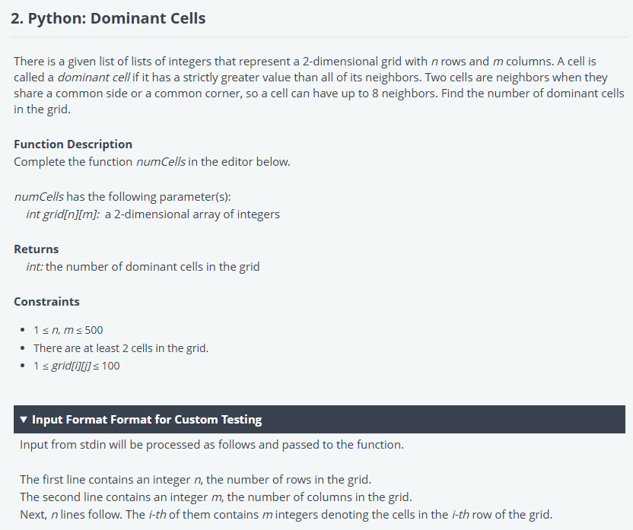

#!/bin/python3

import math

import os

import random

import re

import sys

#

# Complete the 'numCells' function below.

#

# The function is expected to return an INTEGER.

# The function accepts 2D_INTEGER_ARRAY grid as parameter.

#

def numCells(grid):

    # Write your code here

    res = 0

    for i in range(len(grid)):

        for k in range (len(grid[0])):

            val = grid[i][k]

            flag = 1

            for ii in range (max(0,i-1),min(len(grid),i+2)):

                for kk in range(max(0,k-1),min(len(grid[0]),k+2)):

                    if (ii,kk)!=(i,k) and val<= grid[ii][kk] :

                         flag=0

                         break

                if flag == 0:

                     break

            else:

                res+=1

    return res

if __name__ == '__main__':

    fptr = open(os.environ['OUTPUT_PATH'], 'w')

    grid_rows = int(input().strip())

    grid_columns = int(input().strip())

    grid = []

    for _ in range(grid_rows):

        grid.append(list(map(int, input().rstrip().split())))

    result = numCells(grid)

    fptr.write(str(result) + '\n')

    fptr.close()

# Python: Vending Machine

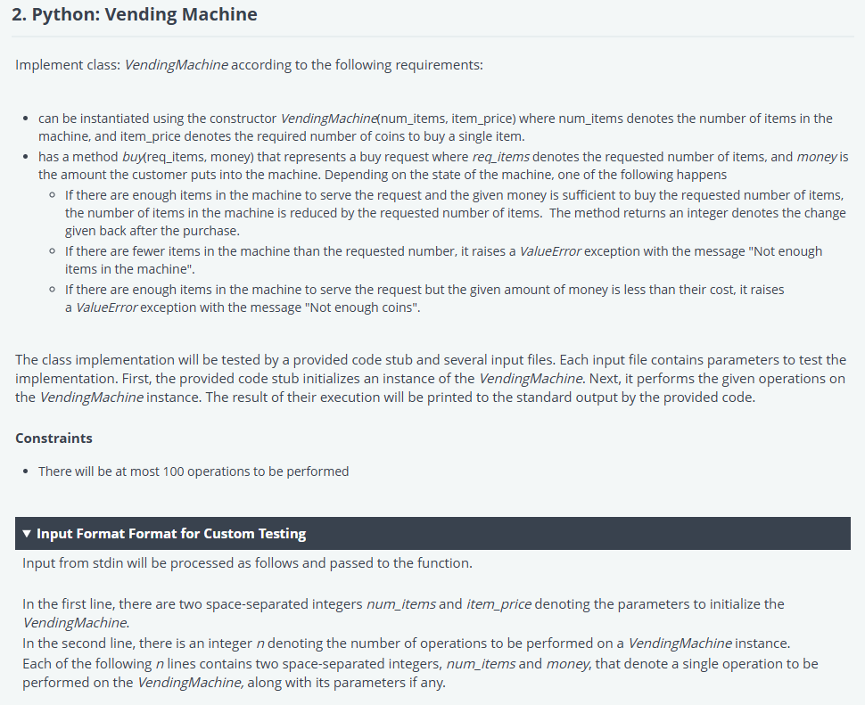

import os

class VendingMachine:

    def __init__(self, num_items, item_price):

        # Initialize the vending machine with the given number of items and item price

        self.num_items = num_items

        self.item_price = item_price

    def buy(self, req_items, money):

        # Check if the requested items are available in the machine

        if req_items > self.num_items:

            raise ValueError("Not enough items in the machine")

        # Check if the provided money is enough to buy the requested items

        total_price = req_items * self.item_price

        if money < total_price:

            raise ValueError("Not enough coins")

        # If both conditions are met, calculate the change and update the machine's inventory

        self.num_items -= req_items

        change = money - total_price

        return change

if __name__ == '__main__':

    fptr = open(os.environ['OUTPUT_PATH'], 'w')

    # Read the number of items and item price

    num_items, item_coins = map(int, input().split())

    # Create the VendingMachine instance

    machine = VendingMachine(num_items, item_coins)

    # Read number of operations

    n = int(input())

    for _ in range(n):

        # Read the requested items and the amount of money provided

        req_items, money = map(int, input().split())

        try:

            # Try to make the purchase

            change = machine.buy(req_items, money)

            fptr.write(str(change) + "\n")

        except ValueError as e:

            # If there's an error (e.g., not enough items or not enough money), write the error message

            fptr.write(str(e) + "\n")

    fptr.close()